Question 1
Dorn (2002; North American Journal of Fisheries Management 22: 280-300) used a Bayesian mixed effects model to develop a Bayesian prior distribution for the steepness of the stock-recruitment relationship for U.S. West Coast rockfish species. The Ricker stock-recruitment relationship can be reparameterized as follows:
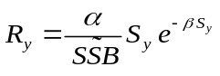
where 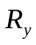 is the recruitment for year y,
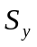 is spawning stock biomass (or a proxy thereof) for year y,
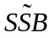 is the spawner biomass-per-recruit in the absence of exploitation, and
 are the parameters of the stock-recruitment relationship.
Use R to fit a linear random effects model to data for 11 West Coast rockfish species treating 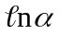 as a random effect and 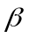 as a (species-specific) fixed effect. Assume that the noise about the stock-recruitment relationship is log-normal and assume that the variation about the stock-recruitment relationship is the same for all species.
The data are stored in the file Home1b.txt (format: Spawning stock biomass, recruitment, species code, spawner biomass-per-recruit).
Evaluate the fits using plots of residuals, random effects, etc.

Steepness is the fraction of the recruitment at the virgin spawning stock biomass expected when the spawning stock biomass is reduced to 20% of its unfished level.

